**Ex No: 10**

**Date:**

**IMPLEMENT CODE OPTIMIZATION TECHNIQUES**

**DEAD CODE AND COMMON SUB EXPRESSION ELIMINATION**

**AIM:**

To write a C program to implement the dead code elimination and common sub expression elimination (code optimization) techniques.

**ALGORITHM:**

* Start
* Create the input file which contains three address code.
* Open the file in read mode.
* If the file pointer returns NULL, exit the program else go to 5.
* Scan the input symbol from left to right.
* Store the first expression in a string.
* Compare the string with the other expressions in the file.
* If there is a match, remove the expression from the input file.
* Perform these steps 5-8 for all the input symbols in the file.
* Scan the input symbol from the file from left to right.
* Get the operand before the operator from the three address code.
* Check whether the operand is used in any other expression in the three address code.
* If the operand is not used, then eliminate the complete expression from the three-address code else go to 14.
* Perform steps 11 to 13 for all the operands in the three address code till end of the file is reached.
* Stop.

**PROGRAM:**

#include<stdio.h>

#include<conio.h>

#include<string.h>

 struct op

{

    char l;

    char r[20];

  }

op[10], pr[10];

void main()

{

  int a, i, k, j, n, z = 0, m, q;

  char * p, * l;

  char temp, t;

  char * tem;

  clrscr();

  printf("enter no of values");

  scanf("%d", & n);

  for (i = 0; i < n; i++)

{

    printf("\tleft\t");

    op[i].l = getche();

    printf("\tright:\t");

    scanf("%s", op[i].r);

  }

  printf("intermediate Code\n");

  for (i = 0; i < n; i++)

{

    printf("%c=", op[i].l);

    printf("%s\n", op[i].r);

  }

  for (i = 0; i < n - 1; i++)

{

    temp = op[i].l;

    for (j = 0; j < n; j++)

{

      p = strchr(op[j].r, temp);

      if (p)

{

        pr[z].l = op[i].l;

        strcpy(pr[z].r, op[i].r);

        z++;

      }

    }

  }

  pr[z].l = op[n - 1].l;

  strcpy(pr[z].r, op[n - 1].r);

  z++;

  printf("\nafter dead code elimination\n");

  for (k = 0; k < z; k++)

 {

    printf("%c\t=", pr[k].l);

    printf("%s\n", pr[k].r);

  }

  //sub expression elimination

  for (m = 0; m < z; m++)

{

    tem = pr[m].r;

    for (j = m + 1; j < z; j++)

{

      p = strstr(tem, pr[j].r);

      if (p)

 {

        t = pr[j].l;

        pr[j].l = pr[m].l;

        for (i = 0; i < z; i++)

{

          l = strchr(pr[i].r, t);

          if (l) {

            a = l - pr[i].r;

            //printf("pos: %d",a);

            pr[i].r[a] = pr[m].l;

          }

        }

      }

    }

  }

  printf("eliminate common expression\n");

  for (i = 0; i < z; i++) {

    printf("%c\t=", pr[i].l);

    printf("%s\n", pr[i].r);

  }

  // duplicate production elimination

  for (i = 0; i < z; i++)

 {

    for (j = i + 1; j < z; j++)

 {

      q = strcmp(pr[i].r, pr[j].r);

      if ((pr[i].l == pr[j].l) && !q)

      {

        pr[i].l = '\0';

        strcpy(pr[i].r, '\0');

      }

    }

  }

  printf("optimized code");

  for (i = 0; i < z; i++)

{

    if (pr[i].l != '\0') {

      printf("%c=", pr[i].l);

      printf("%s\n", pr[i].r);

    }    }   getch();

}

**OUTPUT:**

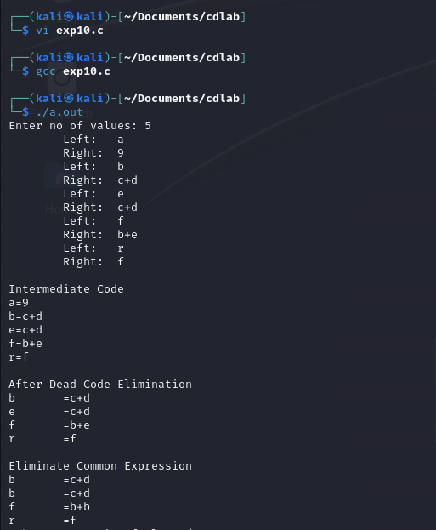

**RESULT:**

Thus, a C program to implement the dead code elimination and common sub expression elimination (code optimization) techniques has been developed.